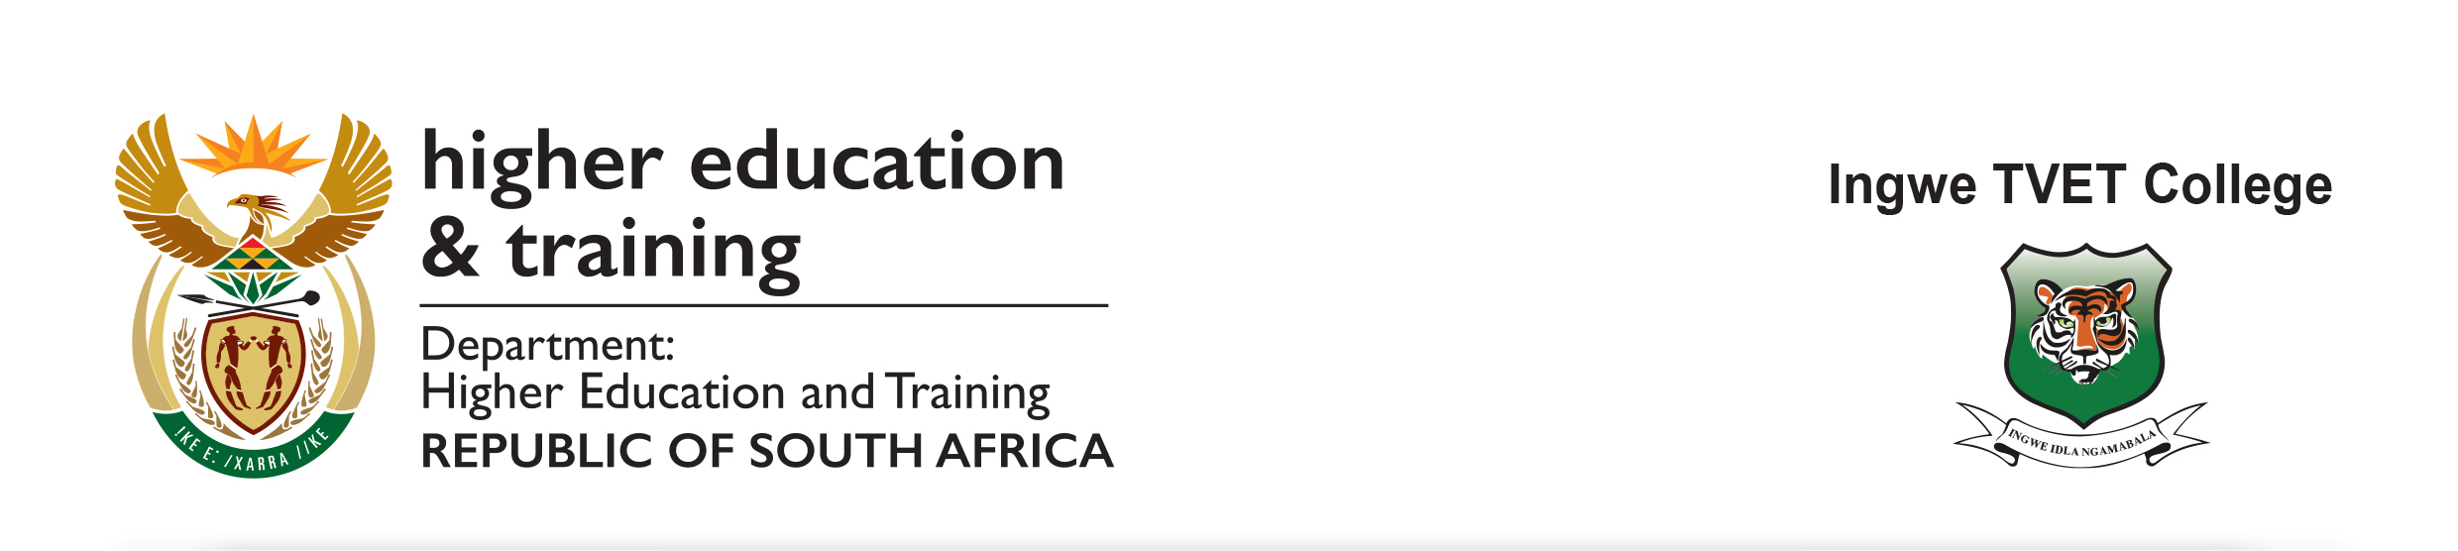

25 January 2022
Erratum

PROVISION OF SECURITY SERVICES FOR PERIOD OF 24 MONTHS FOR NGQUNGQUSHE CAMPUS– BID NO: INGWE/12/2021-A
This erratum is to correct an error on the above bid notice advertised on 21 January 2022 where the enquiries were incorrectly stated.
The Enquiries should be directed to only:
Ms. M. Vunguvungu Tel: 039 940 2142 mvunguvungu@ingwecollege.edu.za (Bidding process)
Mr.MO Hanise Tel: 039 940 2142 mohanise@ingwecollege.edu.za (Technical queries)

Kindly regards
_________________________
Mr. B. Nkonyane
Principal – Ingwe TVET College

