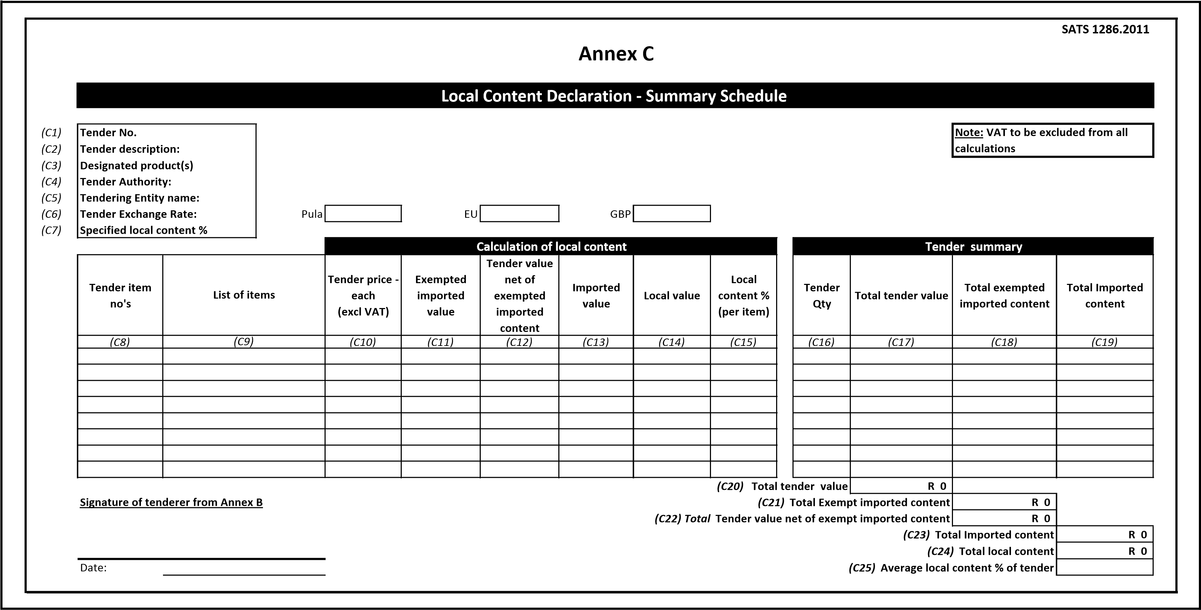

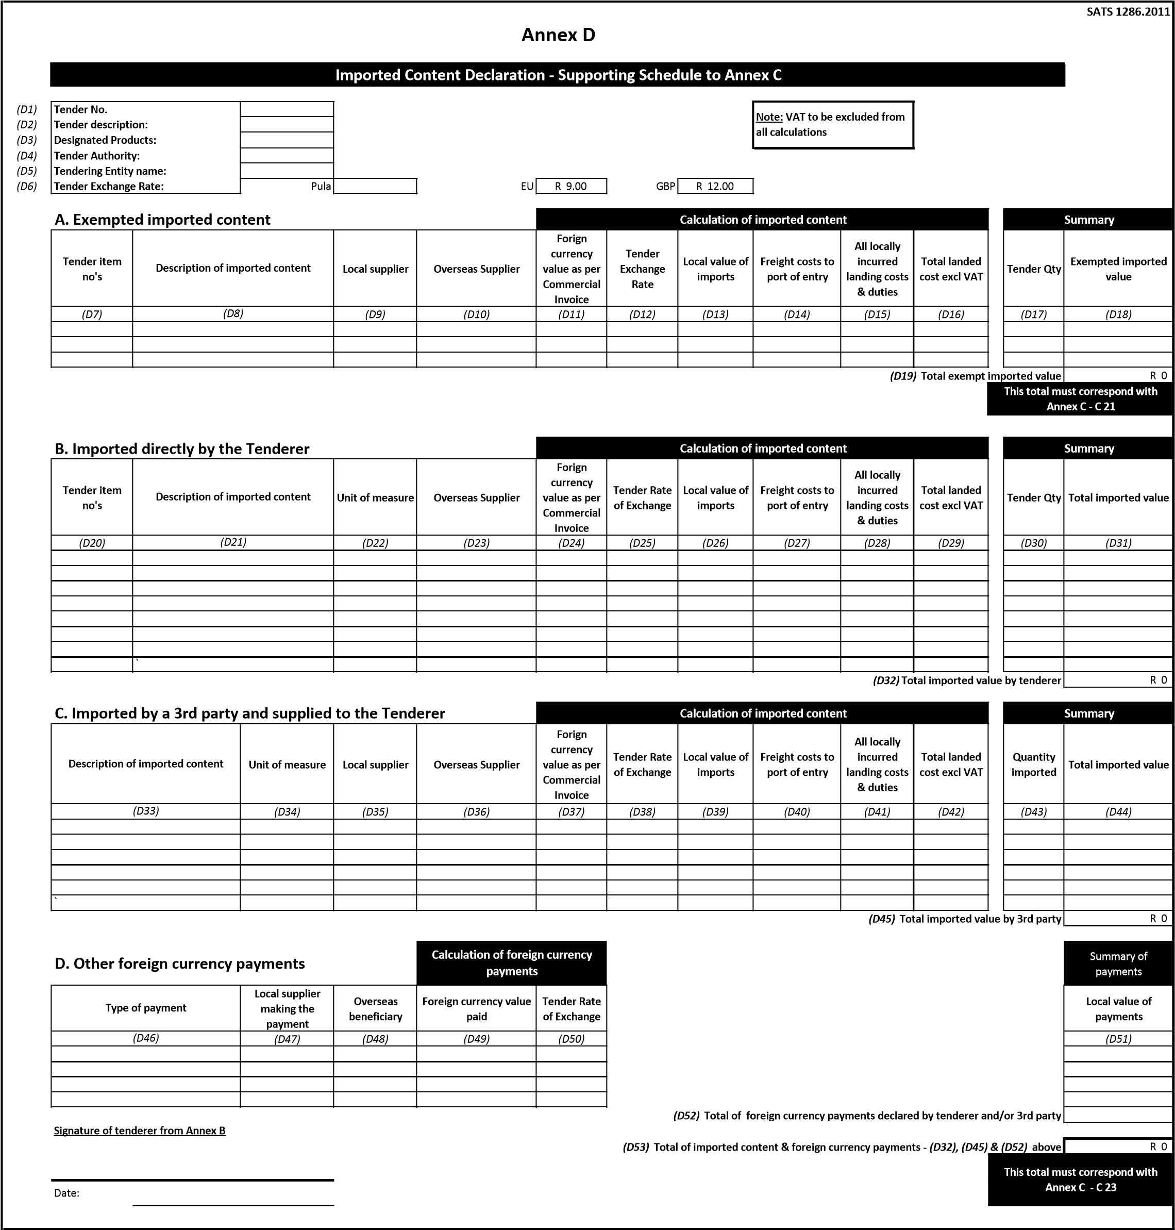

**SATS 1286.2011**

*1)*

*E*

*(*

**Tender No.**

*E*

*2)*

*(*

**Tender description:**

*(*

*E*

*3)*

**Designated products:**

*E*

*(*

*4)*

**Tender Authority:**

*E*

*5)*

*(*

**Tendering Entity name:**

**Local Products**

**(**

**Goods, Services and**

**Works)**

**Local suppliers**

**Value**

% of LC

*(*

*E*

*7)*

*8)*

*E*

*(*

***(***

***E9)***

**Total local products (Goods, Services and Works)**

R 0

*(E10)*

**Manpower costs**

(

Tenderer's manpower cost

)

R 0

*(E11)*

**Factory overheads**

(

Rental, depreciation & amortisation, utility costs, consumables etc.

)

R 0

*(E12)*

**Administration overheads and mark-up**

(

Marketing, insurance, financing, interest etc.

)

R 0

***E13)***

***(***

**Total local content**

R 0

**Signature of tenderer from Annex B**

Date:

**Annex E**

**Local Content Declaration - Supporting Schedule to Annex C**

*E*

*6)*

*(*

**Note:**

**VAT to be excluded from all calculations**

**This total must correspond with Annex C - C24**

**Description of items purchased**